Unpolished

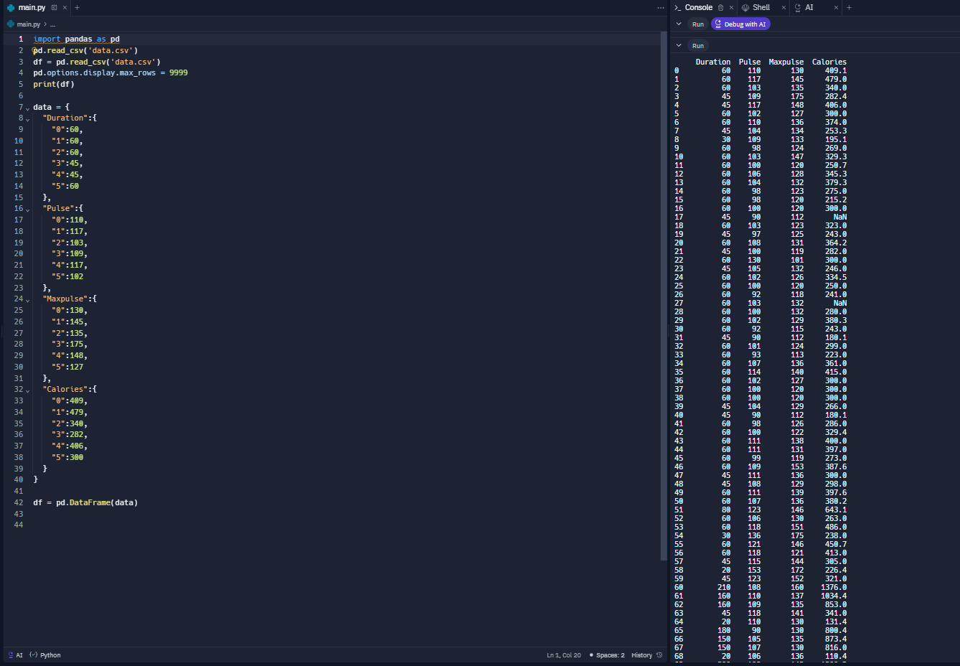

What it looks like

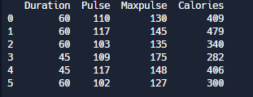

Slightly improved code, reduced number of rows shown, etc. 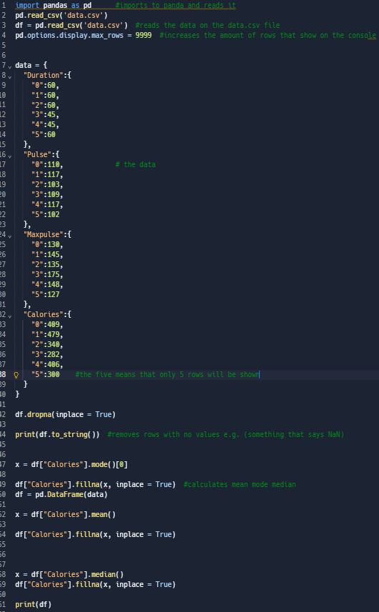

Use of Panda in data science / why it is beneficial.

Panda allows for data to be visualised and analysed easily, it can also be used to clean the collected data by removing errors or unnecessary parts, improving its readability even further.

Limitations of pandas

Pandas has a memory limit for data of 100gb meaning that you can run out of space if you are handling big data potentially.

**EXTENSION** – Find a large data set on the internet and use pandas to output some data from it.

**Data**: Global – Probability of premature mortality from NCDs (2019)

With NCDs meaning non communicable diseases.

**Data source**: World health organisation.

The code: 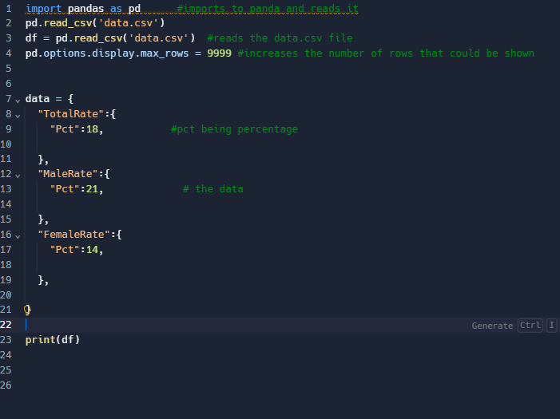

The output:

